Assessment-3
1.Check if a string is a palindrome.
n = input("Enter the string: ")
rev_str = ""
for i in n:
rev_str = i + rev_str
if rev_str == n:
print("palindrome")
else:
print("not palindrome")
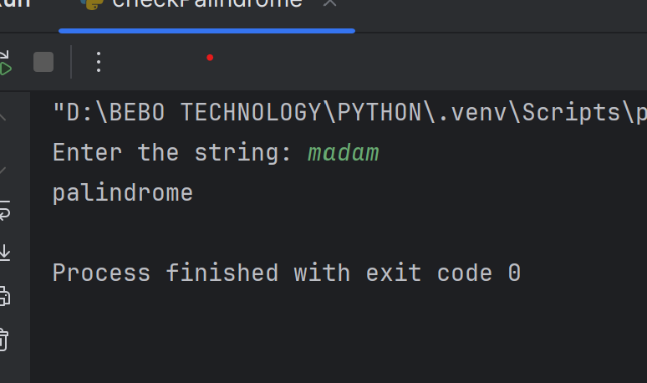
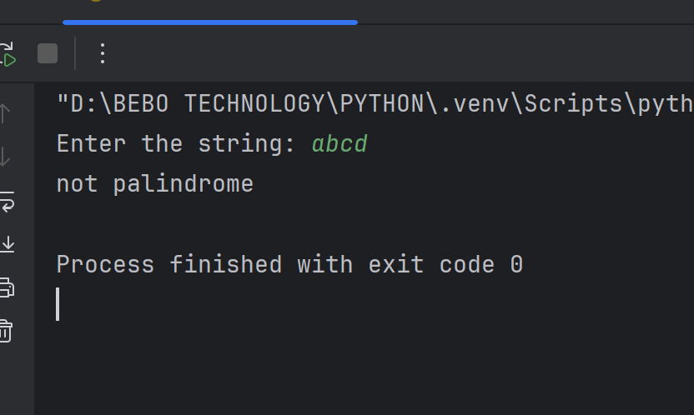
2.Count the frequency of characters in a string
s1 = input("Enter any String: ")
f = {}
for i in s1:
if i in f:
f[i]+=1
else:
f[i] = 1
print(f)
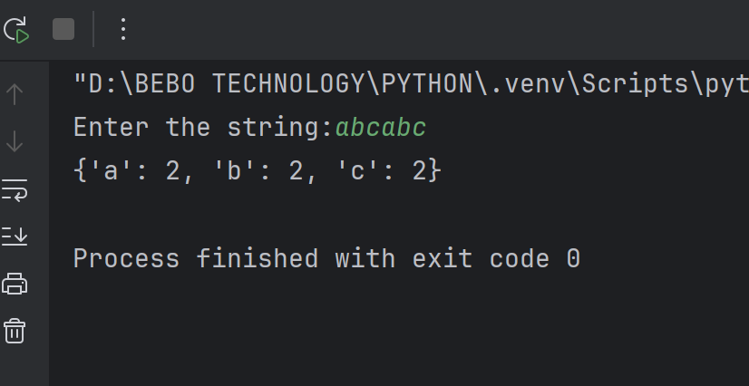

3.Find the first non-repeating character
s1 = input("Enter any String: ")
d = {}
for i in s1:
if i in d:
d[i]+=1
else:
d[i] = 1
for i in s1:
if d[i] == 1:
print("The first non-repeating character is:", i)
break

4.Check if two strings are anagrams
s1 = input("Enter first String: ")
s2 = input("Enter second String: ")
if len(s1)!=len(s2):
print("Not Anagram")
else:
a = sorted(s1)
b = sorted(s2)
if(a == b):
print("Anagram")
else:
print("Not Anagram")
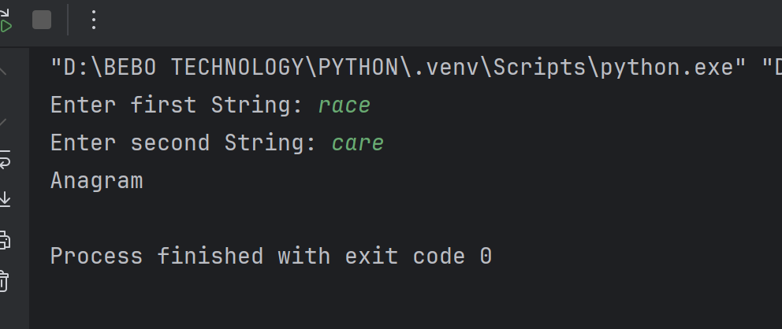
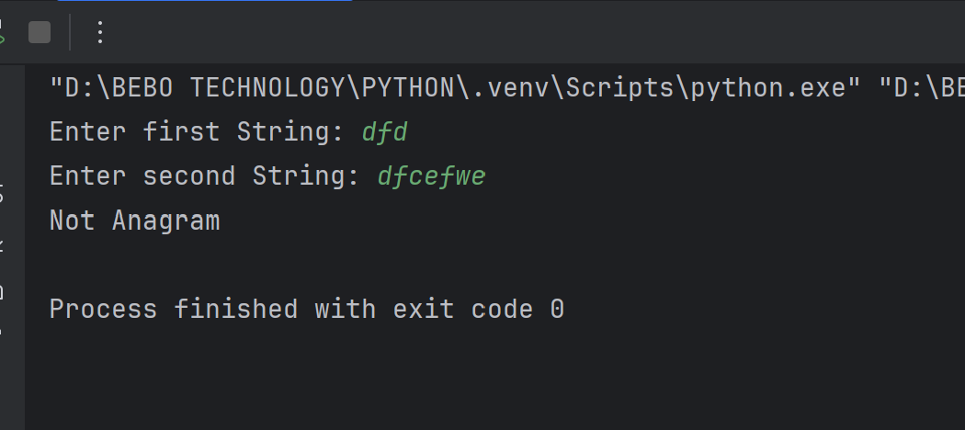
5.Longest substring without repeating characters
n = input("Enter the String: ")
st = 0
m = 0
d = {}
for i in range(len(n)):
if n[i] in d and d[n[i]] >= st:
st = d[n[i]] + 1
d[n[i]] = i
m = max(m, i - st + 1)
print("Length of the longest substring without repeating characters:", m)
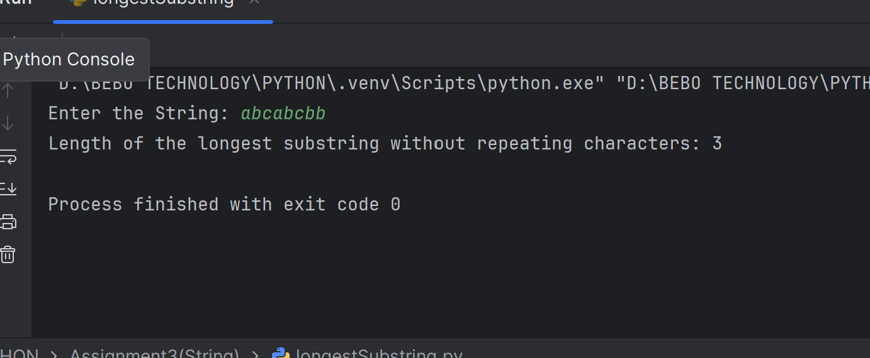
6.Write a Python program that reverses the order of words in a given sentence.
def reverse_characters_in_words(sentence):
words = sentence.split()
reversed_words = [word[::-1] for word in words]
reversed_sentence = ' '.join(reversed_words)
return reversed_sentence
sentence = input("Enter a sentence: ")
print("Sentence with words reversed:", reverse_characters_in_words(sentence))

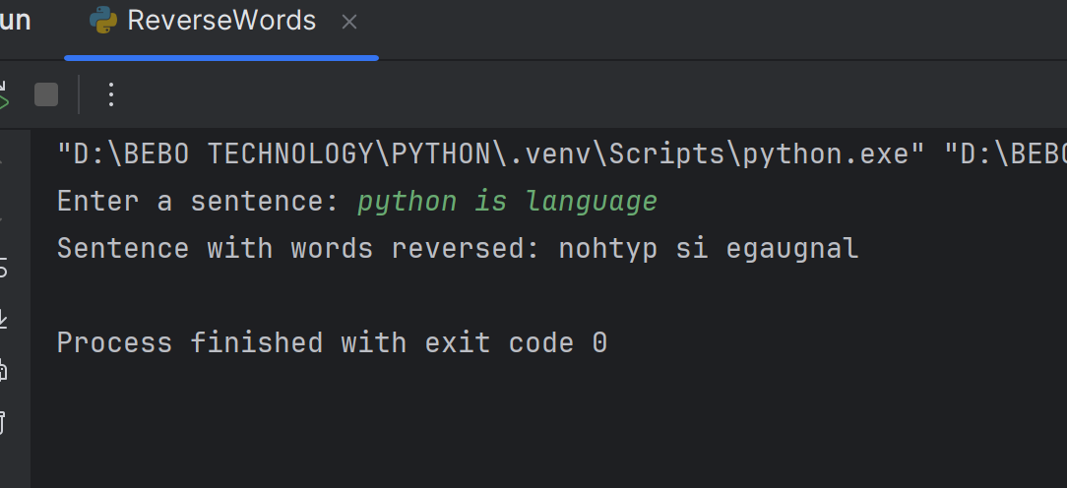

7.Count Vowels in a String
n = input("Enter any String: ")
count = 0
for i in n:
if i in "aeiou":
count+=1
print(count)

8.Write a Python function to find the longest word in a given sentence.
n = input("Enter the string: ")
longest_word = n.split()
length = 0
for word in longest_word:
if len(word) > length:
length = len(word)
print(length)

9.Write a Python program to remove duplicate characters from a string while preserving the order of characters.
def remove_dup(n):
list = []
for i in n:
if i not in list:
list.append(i)
st = "".join(list)
return st
n = input("Enter any String:")
print(remove_dup(n))
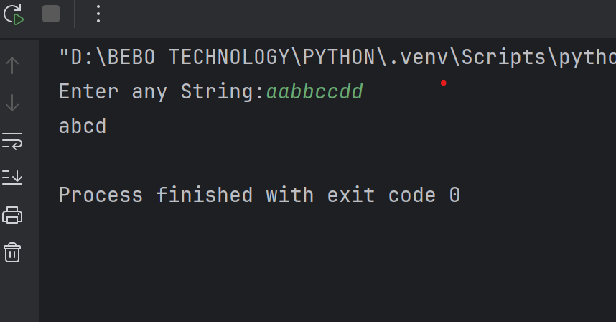
10.Write a Python program to count the occurrences of each word in a given sentence.
s1 = input("Enter the string:")
f = {}
words = s1.split()
for word in words:
if word in f:
f[word] += 1
else:
f[word] = 1
print(f)
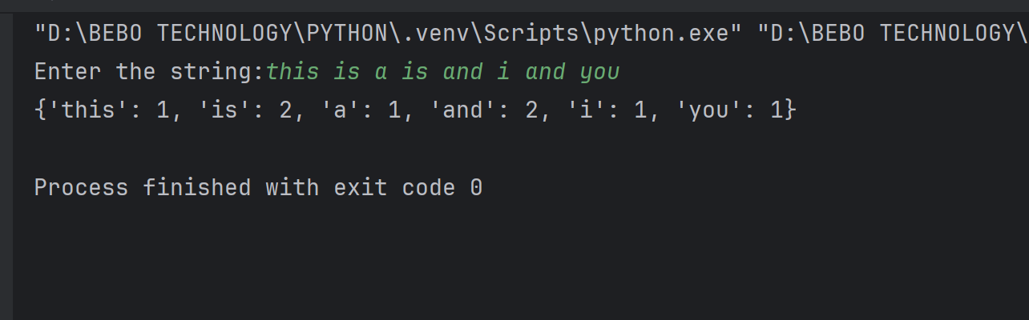

11.Write a Python program to compress a string by replacing consecutive repeating characters with the character followed by its count.
def String_compression(st):
i = 0
compressed = ""
while i < len(st):
count = 1
while i < len(st) - 1 and st[i] == st[i + 1]:
i += 1
count += 1
compressed += st[i]
if count > 1:
compressed += str(count)
i += 1
return compressed
st = input("Enter any String: ")
result = String_compression(st)
print(result)
